
Vol. 1, Issue 05 JULY 2002

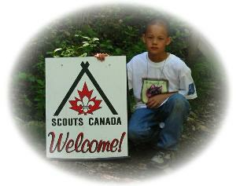

The Scouting Scope
The aim of this UNOFFICIAL, resource-based newsletter is to give Scouters of every section a more focused look at some of Scouting’s more fun and challenging tasks that Leaders and program builders face in the 21st century. The information contained in this resource is from the amalgamated file of Jeff Melvin (chief-editor and contributor). I encourage you to follow the PPP rule with this resource
(Print, Promote, and Pass-along)

You will find that the information in this newsletter will have locally “Field Tested” ideas on GAMES, SONGS, PROGRAM ACTIVITIES, STORIES, MEETING PRAYERS, GROUP CHALLENGE, AND SCOUTING QUOTES that are prepared for use in your programs. If improper credits are given to a contribution, then please feel free to contact me at scouting@canada.com. Best of luck with you’re planning on the adventure trail.

FEATURE ARTICLE

Roundup Ideas…for Packs, Troops and Posts
Vermonter Article by Steve Hoitt
Over the years many different people have tried many ways to recruit new youth and new Leaders into their units. Some ideas are great, some do OK, and others just don't go. We asked several successful Cubmasters and Scoutmasters from around the Council, what they thought were the best ways to reach out to new members and build a strong program. Here are their top answers.
- Program: It is very important that before you recruit anybody that you know exactly what you want to do. Each unit should sit down in August (or earlier) and plan out their entire year, build a budget, and set goals. Plans can always change, but it is important to know where you are going before you get there.
- Sign up Nights: Sign up nights are a great way to kick off your new school year and get parents and kids together, however, they need to be supported by other means of promotion (suggestions 3 through 6). Whatever night you pick, it is always good to ask your current scouts to wear their uniforms to school on that day. Its free promotion. Sign up nights also work best when there are few distractions, so it's a good idea to have a separate program planned for your new youths thus giving you ample time to talk with (and recruit) those new parents.
- School Assemblies: This is the best way to get kids and new adults. Go to your school(s) and hold an assembly with the students, get them excited about the program, and invite them and their parents to a sign-up night several nights later. Your assembly doesn't have to be long it just has to be enthusiastic! If for what ever reasons you can't get anyone from your unit to hold an assembly (but the school would like to do one) there are people on your District Committee and your District Executive who can pitch in and help get it done for you.
- Newspaper and Media: Take full advantage of all the free publicity you can get. Maybe setting up a display in the local school, community center, bank or store. Plaster the town with information about your program. Get your sign-up night in the newspaper and on television.
- Parent/Teacher Nights: Set up a table or display at a Parent/Teacher Night. This is a great way to meet new parents and get them excited about the program. Likewise, many units hold their sign-up night during the first parent/teacher night of the year. This guarantees you a full house, and usually a good turn out, and as long as you have plenty of leaders to meet and greet new parents you will do well.
- Cafeteria Rallies: Not as successful as school assemblies, but try visiting your local school during lunch, talk up the program table by table, pass out wrist bands, distribute fliers and invite the kids with their parents to your sign up night. (Fliers and wrist bands can be printed for your unit free of charge through your District Executive and/or your District Membership Committee).
- Guest Night: This always works well for Youth Scout Troops and Explorer Posts or as a follow-up program for Packs. Ask each member of your unit to invite a guest to your next meeting, offer incentives for current scouts who recruit another member to your unit (i.e. the recruiter patch or special gift). Caution: If you're going to do a guest night you better have a good program. No one wants to join a boring organization.
- Youth Fact & Career Surveys: Many units, mostly Troops & Posts have tried surveying the kids in their local school to find out what they like to do or what their career interests are. Kids whose interests match the program of the unit are invited to be part of the program. Youth Fact Surveys (for troops) and Career Surveys (for posts) are also available through your District Executive.
- Church Promtion & Youth Centers: When you decide to hold your sign up night it is always a good idea to give it your best effort and explore every possible recruitment tool. Another great opportunity for getting new youths (and usually well qualified leaders) is promoting your program at your local church(es). Get your sign up night in the church newsletter or bulletin, visit the Sunday School or CCD classes just prior to your sign up night and hold quick assemblies. Visit any local youth centers, plaster the area with posters and talk to the kids about your Scout program.
- Leader Recruitment: Every youth member that joins your unit should also mean another adult volunteer to help. The quickest way to get more adult support is to get more youth members, and the more adults you have the easier your job will become. Get your parents involved with all of your activities, don't give them the opportunity to be bystanders, remember this is a family program. It is usually a good idea to develop a list of positions that need to be filled by parents prior to your sign up night. This way you can constantly try to match every parent up with each of your needs.
- Make Recruitment a Year-Round Effort: Set goals for how many Cubs, Scouts, Explorers and Leaders you would like in your unit. Assign a membership coordinator within your committee who will work to carry out a year-round roundup plan. And keep trying new ideas. Just because something doesn't work for you the first time doesn't mean it's a bad idea, keep trying! Persistence always pays off in the end.
Finally, everyone who gave feed back for this article said the same thing. When you do your roundup be a little selfish. Get into the school as early as possible, do your roundup, have an enthusiastic sign-up night and get your leaders in place before other town organizations start signing up parents. Most of the time its the same handful of parents in town who are the key leaders in a majority of the local activities. You deserve first chance at getting Mr. or Mrs. "Right" as your new Cubmaster, Scoutmaster, Post Adviser or Den Leader. Mr. and Mrs. "Right" have limited amounts of time, just like the rest of us, and if they are the perfect leader, not only will their family benefit by the program you and your committee have created, but all of the other families will too.
Good Luck and Best Wishes with your fall roundup.
Nothing lowers the level of conversation more than raising the voice.
- Stanley Horowitz -

Games for Your Meeting

Where Have You Been
Directions: Starting with the first letter of the alphabet, each Cub must say his name and tell a story of where he has been and what he brought back from there. As the game continues, the Cub must repeat where the three Cubs before him went and what they brought back.
Example: (The first Cub...) My name is ______ and I have been to Alaska. I brought back some Apple Pie. (The next Cub. . .) My name is ______ and I have been to Bay Town. I brought back some Black Berries (The next Cub...) My name is _____ and I have been to Cleveland. I brought back a Camp stool (repeat the other two Cubs stories), etc.

Independence Tag
‘It’ pursues the rest of the players and tries to touch one of them. When one has been touched, they must keep their hand on the spot where they were touched and pursue the others. Their hands can not be freed from this spot until they have been tagged by someone else. The idea is to tag people in inconvenient places ... on the ankle, knee, etc.

Boston Tea Party
Have one team as the Patriots and the other the Redcoats. The Patriot wears one feather in a headband since they were disguised as Indians at the real tea party. The Redcoats have a patch of red on a sheet of white paper pinned on their back. Place two teapots at the finish line and place a bucket full of water at the start line. Each team has one cup. First youth scoops a cupful of water from the bucket, races to his team’s teapot and dumps the water into it. They race back and then give their cup to the next. First team to fill its teapot wins.

Ice Cream Relay
Divide the youth into pairs. Give each youth a dish of ice cream and a spoon. The youth race to see who can eat their ice cream first. The trick to the game is the spoons are tied together by a six inch piece of string. The first pair to finish their ice cream wins. They have to eat together.

Together Everyone Achieves More!

Program Ideas and Hints

PLASTER FOOT OR HAND CAST

You will need:
Shoe box; Sand; Plaster of Paris; Foil; Wire; Beads; Feathers (optional); Permanent marker.

1. Line the inside of the shoe box with foil. Fill half way with sand.
2. Sprinkle the sand with water, just enough so it holds together and takes an imprint.
3. Place your foot or hand in the sand and press firmly.
4. Mix plaster, following the directions on the package.
5. Pour the plaster into the imprint in the sand.
6. after it has set, but not too hard, poke 2 holes in the top two sides of the imprint. Don't take the plaster out.
7. When the plaster is completely dry (or at the next meeting), brush sand off and place the wire in the holes, threading on the beads. Stick feather into bead with a little dab of glue at the tip.
8. With a marker, write what you would like on the imprint.

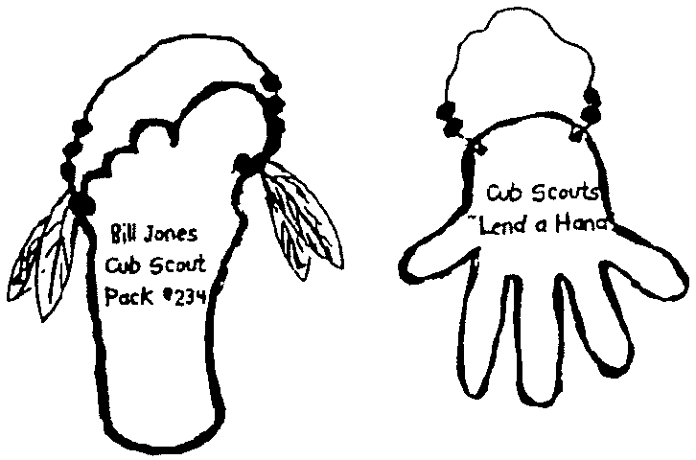

POWER BARS

3/4 cup (1 1/2 sticks) butter, plus 2 tsp. for the pan, at room temperature
1/3 cup packed brown sugar
1/4 cup all-purpose flour
1 tsp. vanilla extract
5 cups unsweetened granola

1. Place an oven rack in the center of the oven. Preheat the oven to 375.
2. Using a paper towel spread the 2 teaspoons of butter evenly over the bottom and sides of a 9" baking pan.
3. Melt 3/4 cup butter in a small saucepan over medium heat. (Don’t let it burn.) Pour it into a mixing bowl.
4. Add brown sugar, flour, and vanilla to the butter and stir thoroughly.
5. Add granola and stir very well to coat all the granola with the butter mixture.
6. Spoon the granola mixture into the baking pan. Press it flat.
7. Bake in the oven until the top is golden brown, 15 to 20 minutes.
8. Place the pan on a cooling rack and let it cool completely, at least 30 minutes.
9. Cut the granola in the pan into 4 strips lengthwise and 3 strips crosswise. Remove the bars from the pan with a spatula.

Makes 12 bars

Songs & Yells

Big Thumb: Hold out a hand at arms length, make a fist with the

Beaver: Cut a tree by tapping front teeth together, slap your tail by
slapping a palm against your thigh, then yell, "TIMBER!"

Broken Trolley: Pull the bell rope as if ringing a bell, repeating
"CLUNK, CLUNK, CLUNK."

Call the Hogs Yell: SOOOOOOOO EEEEEEEE, SOOOOOOOO, and EEEEEEEE!!!!!!! PIG, PIG, PIG!!!

Carpenter: Pretend to be holding a hammer in one hand and a nail in the other. Start pounding the nail with the hammier while saying, "Bang,
Bang, Ouch".

Cheery: Pick a cheery, roll in your mouth, then spit the pit out with a
loud "P-TUU."

Clam: Fold hands together, interlocking fingers. Make noise by pressing
Palms together.

Bug Juice (Tune: Grand Old Duke of York)

At camp with the Youth Scouts
They gave us a drink.
We thought it was Kool-Aid,
Because it was pink.

But the thing that they told us
Would've grossed out a moose,
For that great tasting pink drink
Was really bug juice.

It looked fresh and fruity,
Like tasty Kool-Aid,
But the bugs that were in it
Were murdered with RAID!

We drank it by gallons;
We drank it by tons.
And the next morning,
We all had the runs!

So the next time you drink bug juice,
And a fly drives you mad,
He's just getting even,
'Cause you swallowed his dad.

CHICKEN LIPS AND LIZARD HIPS (Tune: Supercalifragilistic)

Oh, when I was a little kid, I never liked to eat.
Mama'd put things on my plate,
I'd dump them on her feet
But then one day she made this soup,
I ate it all in bed.
I asked her what she put in it
And this is what she said:

CHORUS:
Oh, chicken lips and lizard hips and alligator eyes
Monkey legs and buzzard eggs and salamander thighs.
Rabbit ears and camel rears and tasty toenail pies.
Stir them all together; it's Mama's soup surprise.
I went into the bathroom and stood beside the sink.
I said, "I'm feeling slightly ill,
I think I'll take a drink."
Mama said "I've just the thing,
I'll get it in a wink,
and it’s full of lots of protein and vitamins I think."
CHORUS
Scouters’ 5 (meeting stories)

ATTITITUDES…
“The longer I live, the more I realize the impact of attitude on life. Attitude to me is more important than facts. It is more important than past. Than education, than money, than circumstances, than failures, than successes, than what other people think, say or do.

It is more important than appearance, giftedness, or skill, it will make or break a company…a church…a home. The remarkable thing is we have a choice to make ever day regarding the attitude we will embrace for the day. We cannot change our past…we cannot change the inevitable. The only thing that we can do is play the one string we have, and that is our attitude.

…I am convinced that life is 10% what happens to me and 90% of how I react to it. And so it is with you…we are in charge of our attitudes.”
-Charles Swindle-

Failure List
 Einstein was four years old before he could speak.
 Isaac Newton did poorly in grade school and was considered unpromising."
 Beethoven's music teacher once said of him, "As a composer, he is hopeless."
 When Thomas Edison was a youngster, his teacher told him he was too stupid to learn anything. He was counselled to go into a field where he might succeed by virtue of his pleasant personality.
 F. W, Woolworth got a job in a dry goods store when he was 21, but his employer would not permit him to wait on customers because he "didn't have enough sense to close a sale."
 Michael Jordan was cut from his high school basketball team. Boston Celtics Hall of Famer Bob Cousy suffered the same fate.
 A newspaper editor fired Walt Disney because he "lacked imagination and had no good ideas."
 Winston Churchill failed the sixth grade and had to repeat it because he did not complete the tests that were required for promotion.
 Babe Ruth struck out 1,300 times.-a major league record. He was also the most notorious womanizer in the sports world.
A person may make mistakes, but isn't a failure until he (or she) starts blaming someone else. We must believe in ourselves, and somewhere along the road of life, we must meet someone who sees greatness in us, expects it from us, and lets us know it. It is the golden key to success.

Do You Need Drugs to be a Grownup?
A group of Arapaho Indians decided it was time to prove to the tribe elders that they were old enough to be considered men. By custom, the rite of manhood included living alone for one week in the wilderness. Each youth was instructed to only take a knife with him and come back seven days later and tell of his adventures. One youth, wanting to prove that he was more of a man than the others, decided that he would climb the snow-capped mountains for his week of adventure. Surely, living in the snow and cold is a hardship that the elders must agree that only a man could endure. So, he walked an entire day across the plains to the foot of the mountains. He climbed halfway up the mountains to the snowline when a snake spoke to him.

"Help me," the snake cried.
"Why should I help you, a rattlesnake? You are known to bite and kill people," replied the Arapaho brave.
"I am cold and almost frozen. Please put me in your warm shirt and take me down the mountain to where it is warm where I can survive," said the rattlesnake.
"How do I know that you are not going to bite and kill me?" asked the brave.
"Why should I bite the person who saves my life?" replies the snake.
"Ok. I do not like to see anyone die. Promise you won't bite me?" asked the brave.
"I Promise," replied the snake.
So the Indian youth placed the snake in his shirt and walked down the mountain. As he opened his shirt to let the snake out, the rattlesnake bit him.

"WHY DID YOU BITE ME? You promised you wouldn't bite and kill me!" yelled the young brave.

The snake replied, "You knew who I was when you picked me up. You have nobody to blame for your death but yourself."

Today scouts, one doesn't prove his maturity by living alone in the wilderness anymore, but instead shows that he is a adult by living wisely in the streets and making good decisions by himself. There are rattlesnakes hiding in the streets today that go by the names of marijuana, cocaine, crack, speed, and acid drugs. Drugs will falsely promise a lot of good times and laughs, but will instead lie to you, get you to steal and break the law in other ways, and if not kill you, rob you of your health and brains. The few hours of chemical-induced pleasure may cost you the rest of your life in permanent brain damage and physical disability.

When you decide to prove to others that you are mature enough to be an adult man, prove it by making the right choice not to do any drugs and stick to that decision. Ok?

Everything I need to know about life,
I learned from Noah's Ark...
✓ Don't miss the boat.
✓ Remember that we are all in the same boat.
✓ Plan ahead. It wasn't raining when Noah built the Ark.
✓ Stay fit. When you're 600 years old, someone may ask you to do something really big.
✓ Don't listen to critics; just get on with the job that needs to be done.
✓ Build your future on high ground.
✓ For safety's sake, travel in pairs.
✓ Speed isn't always an advantage.
✓ The snails were on board with the cheetahs.
✓ When you're stressed, float a while.
✓ Remember, the Ark was built by amateurs; the Titanic by professionals.
✓ No matter the storm, when you are with God, there's always a rainbow waiting.

Stop the Coughin’
As told by Richard and Judy Dockery Young

Once upon a time, a long time ago, there was a country youth who went to town to see the sights. He didn't have much money, so he couldn't stay in a hotel. He decided to sleep where no one would bother him: he went to sleep in the cemetery.
In the middle of the night, he woke up when something bumped him on the foot. He looked up, and there was a shiny rosewood coffin. He got up and moved. The coffin moved, too. He moved a little further. The coffin moved a little further. He got up and started to run. The coffin floated up into the air and started to follow him.
He ran out the gate of the graveyard. The coffin followed him. He ran across the flower
bed, trampling the flowers. The coffin came, too. He ran through the poultry yard and scared all the chickens. The coffin scared them, too.
He ran through the park and knocked over a picnic table. The coffin knocked one over, too. He ran through the stable and scared all the horses. The coffin scared the horses, too.
He ran through the grocery store and pushed over the cracker barrel. The coffin pushed one over, too.
He jumped through the back window and broke the window out. The coffin broke a window out, too.
He ran into the drug store and there it all ended.
He opened a box and ate some cough drops ... and stopped the coughin'.
SKITS (entertainment)

The Raisin
Need: 5 Scouts (1 to be a table).
1st Scout comes out: Gets down on all fours, pretending to be a table.
2nd Scout comes out, looks at the table and declares;
2nd SCOUT: "Ahh, a fly, I think I'll pull it's wings off" Proceeds to pick it up, pluck the wings, put it back
on the table, and walks off.
3nd Scout comes out, looks at the fly on the table and says;
3rd SCOUT: "Oh, a fly with no wings, I think I'll pull it's legs off", With great precision and animation,
picks up the fly, removes it's legs, and puts it back and walks off.
4rd Scout comes out, looks at the fly and announces;
4th SCOUT: "Say, a fly with no wings and no legs, I think I'll pull it's head off." Then proceeds as the
other Scout before him.
Last Scout comes out looks at the table, then carefully inspects the object with out picking it up and says
very quickly
LAST SCOUT: "A raisin !" and quickly picks it up and puts it in his mouth

The Lost Lollipop
Need: 2 scouts.
Small youth is sitting, crying
Passer-by #1: (Enters) What's wrong little youth, why are you crying?
Youth: (Sobbing) I lost my lollipop !
Passer-by #1: Have you looked for it ?
Youth: (Continues to sob) Oh, yes, I've looked under my bed, in my sock drawer, and even in Charlie's
pocket.
Passer-by #1: I've heard that chanting often works. You think very hard about the lollipop until you can
see it in your mind, and chant 'lollipop' over and over again.
Youth: (Closing eyes tightly) Big red yummy lollipop, big red yummy lollipop, big red yummy lollipop.
Passer-by #1: (Nods approval and strolls out)
Youth: (Continues chanting for a while, then starts crying again)
Passer-by #2: (Enters) What's wrong, little youth ?
Youth: (Sobbing) I lost my lollipop, and I hunted and hunted, then this man told me to chant, and I did, and
it didn't work !
Passer-by #2: Chanted ?
Youth: Yeah, like this (Demonstrates, then starts to cry)
Passer-by #2: Don't cry little youth. Maybe we need more help.
Youth: (Turns to audience) You're my only help to get my lollipop back. Everybody, very softly now, chant
with me, "Big red yummy lollipop, big red yummy lollipop, big red yummy lollipop." (Gets everyone doing
it in unison) Great ! I think it's working, keep going now.
Passer-by #1: (Re-enters) Hi little youth. Did it work ?
Youth: (Loudly) No, it didn't, but I did find a whole lot of suckers!

"On a good team there are no superstars. There are great players who show they are great players by being able to play with others as a team. They have the ability to be superstars, but if they fit into a good team, they make sacrifices, they do things necessary to help the team win. What the numbers are in salaries or statistics don't matter; how they play together does."
-- Red Holzman --

TID-BITS…

Fixing Fire Damage
Look around any spot that has been used as a campsite and you will usually find half a dozen fireplaces. Man seems to have a nesting instinct that requires him to make his own personal hearth before he is at home in a place.
A recent study conducted by the Sierra Club Outing Committee shows that, each time a camper uses an open fire, 1.2 square metres (4 square ft.) of ground is destroyed and 5 kg (11 lbs.) of wood consumed. We can not continue to use open fires indiscriminately.
Help fix fire damage. If you come across a site with several big or little fireplaces, you can obliterate many of them. Where fires were built on grassy spots, clear away the ashes, litter and rocks, then place a thick layer of fallen evergreen needles over the burned-over spot. Your efforts will go a long way to help restore a damaged area.
Thanks to Mike Marlow and
The Grapevine, Fruitbelt District, Ont.

One Minute Boil
Save fuel, time, and the possibility of boil-over damage to your camp stove by practising the One Minute Boil. Bring food to a boil, reduce heat and boil gently for one minute, then cover the pot tightly and remove from the heat source for 10 minutes or so. The food continues to cook by its own heat and both you and your stove are free to prepare another course.
Save the Popcorn Pot
To avoid burning the pot when you're popping popcorn, line the bottom with foil, shiny side up...
Daymar Adventure Centre, Ont.

Coffee & Eggs
Save having to use another pot in the morning. After the coffee has finished brewing, put an egg in the coffee pot for five minutes. Result? A soft boiled egg, ready to eat. Good coffee, too.
Hazel Tagg, Red Deer, Alta.

Never forget these four points about scouting:

➲ The Youth are the reason for Scouting. They own the movement.

➲ Anything that supports #1 is good,

➲ Anything that diminishes #1 is bad.

➲ In cases of confusion, consult #1.

Cocoa Powder Tire Trick
A puncture in your bicycle tire? When you are repairing it, pour in about a teaspoon of cocoa powder through the valve hole. The next time the tire gets a puncture while you're out riding, the air rushing out will draw the powder with it and quickly choke the hole, giving you only a slow leak. As a consequence, rather than having to push the bike home for repairs, you will be able to replace the air lost in the initial rush and ride back.
Thanks to Scouting in New South Wales, Australia

Camp Repairs
To banish paint odour when repainting the cookhouse, add two tablespoons vanilla extract to each quart of paint. A large cut onion placed in a big pan of cold water will also absorb paint odour.
(Hazel Tagg)
Use a match stick to fill out a hole where a screw needs tightening.

Rub candle stubs along the edge of a saw to help it glide better sticky drawers also respond to this treatment.
(Scouting U.K.)
RECIPIES for Those
Who Eat…

Rainbow Rice and Tuna Fish
  1/3 c raw uncooked (NOT instant) rice.
  2/3 c chicken broth (canned is fine).
  2 Tbsp (divided) butter
  1 sm (6 oz 0r 170 g) chunk Tuna, drained.
  1 Tbsp lemon juice
  1/3 c diced onions
  1/3 c red bell peppers
  1/3 c green bell peppers
  salt and pepper to taste
How to Prepare:
Melt one Tbsp of butter in a 1 quart saucepan, add rice, and stir until all the grains are coated. Add the chicken broth to the rice, cover and place pan over a very low flame. (total heating will be 15 minutes, followed by at least 5 minutes standing time).
After the rice has cooked for 15 minutes, turn off the flame under the rice, but do NOT remove the cover. Melt one Tbsp of butter in a frying pan; heat the onion and bell peppers until soft. Add the lemon juice and the drained can of tuna. Heat mixture for an additional 3 to 5 minutes or until the tuna is warmed. Remove the cover on the rice and stir in he heated onion, bell pepper and tuna mixture and serve. Salt and pepper to taste.

The Making of a Challenging Program
• It must have strong appeal for youth
• It should offer variety so each youth can do the things they like.
• It should instil the deeper values of Scouting.
• It has to be FUN.
• It should contribute toward the development and maintenance of strong family relationships.
• It should be simple, within the capability and interests of both Scouting Members and Parents.

Meeting Prayers
(Universal & Non-generic)

-Submission by Martin Drapeau-

ADDAMS FAMILY GRACE
(Tune-Addams Family Theme Song)

We thank you Lord for giving
This food we need for living
So bless us while we eat it
Because we really need it
Amen, Amen, Amen, Amen, Amen
Let's eat!

Lord, Thank you for bringing us together in the Family of Scouting
Bless our Group and all its Members
Help us to be loyal to our Promise, to each other, and to ourselves
And in everything that we do, help us to put other people first.
Forwarded by Owen Sayers
Prayer for an Outing
We thank you, O God, for all the loveliness of nature, which is your special handiwork. Everything is wonderfully made with your special care.
Help us to understand our world more and more and know how we can help take care of the things, which you have made, and keep them beautiful as you meant for them to be. Amen
An optimist may see a light where there is none, but why must the pessimist always run to blow it out?
- Michel De Saint-Pierre -

Scouter's Prayer
Dear Lord, from your judgment seat on high,
Look down on a Scouter such as I.
Search me through and find me whole,
Then help me Lord to reach my goal.
Help me Lord to work for Thee.
Guard my homeland - Keep it free.
Help me to work with others and be kind.
Helpful with my hands and mind.
Keep me Lord, both well and strong
To help our growing youths along.
Control my thoughts, keep them right,
sound, clean weapons for life's fight.
Protect my morals, keep them high,
Grant this to a Scouter such as I.
The Final Thoughts to
Take Home…

"Treat people as if they were what they ought to be, and you help them to become what they are capable of being."
Johann Wolfgang von Goethe (1749-1832)

"There is only Me stopping Me from being Successful."
Mike Pritchard --- North Wales, UK
"Every boxer gets knocked down, The champions get back up and fight another round."
"And in the end, it's not the years in your life that count. It's the life in your years."
Abraham Lincoln

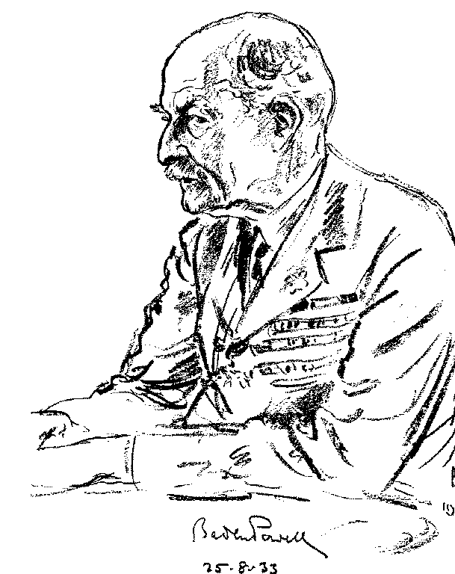
Please send your
ideas and hints to
“The Scout Scope”

SCOUTING@canada.com



